1.C1 extends C2
Code:
package basics;
class C2 {
void displayC2() {
System.out.println("This is C2");
}
}

class C1 extends C2 {
void displayC1() {
System.out.println("This is C1");
}
}

public class Main {
public static void main(String[] args) {
C1 obj = new C1();

obj.displayC2();
obj.displayC1();
}
}
Explanation:
- C2 is the parent class.
- C1 is the child class.
- C1 inherits C2 using extends.
- displayC2() is a method of C2.
- displayC1() is a method of C1.
- Main contains the main() method.
- An object obj of C1 is created.
- obj can access the inherited method displayC2().
- obj can also access its own method displayC1().
- The program demonstrates single inheritance.

Output:
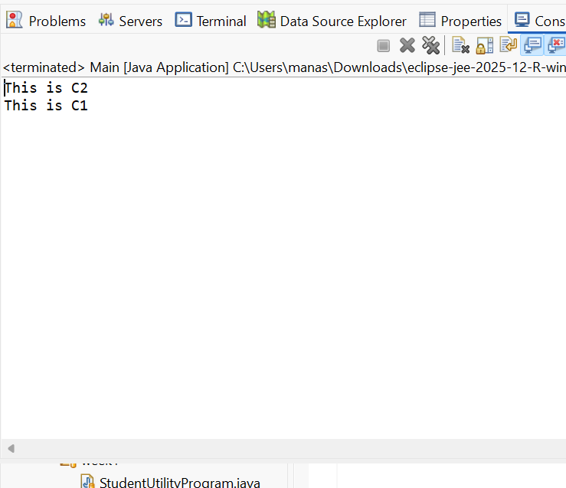
2. C1 extends C2, C3
Code:

//class C2 {
//}

//class C3 {
//}

// ERROR: Java does not support multiple inheritance using classes
// class C1 extends C2, C3 {
// }
interface A {
void showA();
}

interface B {
void showB();
}

class C implements A, B {

public void showA() {
System.out.println("Class C inherits A");
}

public void showB() {
System.out.println("Class C inherits B");
}
}

public class MultipleInheritence {
public static void main(String[] args) {

C obj = new C();

obj.showA();
obj.showB();
}
}
Explanation:
- The program demonstrates multiple inheritance using interfaces.
- Interface A contains the method showA().
- Interface B contains the method showB().
- Class C implements both A and B.
- Java allows a class to implement multiple interfaces.
- Class C provides the implementation for showA().
- Class C also provides the implementation for showB().
- An object obj of class C is created.
- obj.showA() and obj.showB() are called using the same object.
- Thus, the program shows how multiple inheritance is achieved through interfaces in Java.
Output:
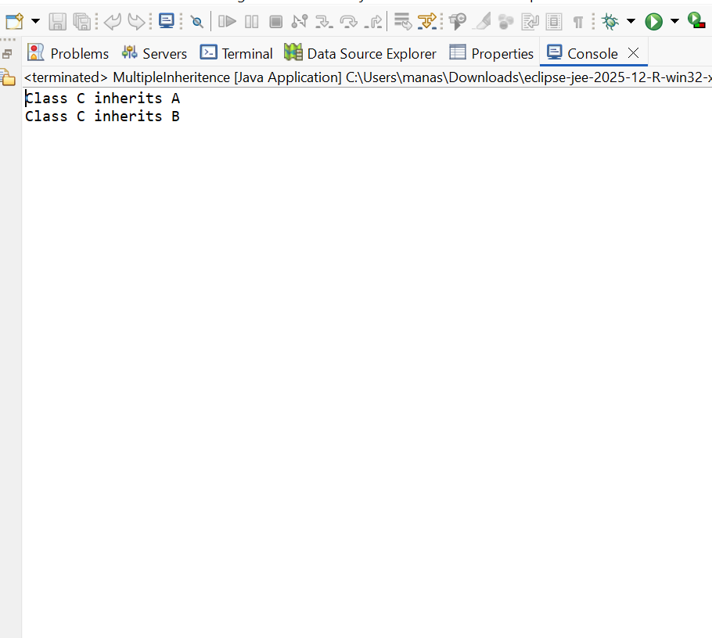
3. C1 implements I1
Code:
package basics;
interface TestInterface {
void display();
}
class TestClass implements TestInterface {
public void display() {
System.out.println("TestClass implements TestInterface");
}
}
public class Case3Example {
public static void main(String[] args) {
TestClass obj = new TestClass();
obj.display();
}
}
Explanation:
- TestInterface is an interface.
- It contains the method display().
- TestClass implements TestInterface.
- The display() method is defined inside TestClass.
- The method prints a message on the screen.
- The main() method is present inside Case3Example.
- An object obj of TestClass is created.
- The display() method is called using obj.
- The message "TestClass implements TestInterface" is displayed.
- This program demonstrates interface implementation in Java.
Output:
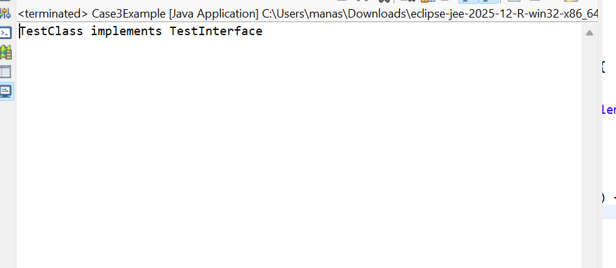
4. C1 implements I1, I2
Code:
package basics;
interface I1 {
void display1();
}
interface I2 {
void display2();
}
// Stud class implements both interfaces
class Stud implements I1, I2 {
public void display1() {
System.out.println("Stud implements I1");
}
public void display2() {
System.out.println("Stud implements I2");
}
}
public class Case4Exam {
public static void main(String[] args) {
Stud obj = new Stud();
obj.display1();
obj.display2();
}
}
Explanation:
- I1 is an interface with the method display1().
- I2 is another interface with the method display2().
- Stud implements both interfaces using implements I1, I2.
- Stud provides the implementation of display1().
- Stud also provides the implementation of display2().
- Both methods print messages on the screen.
- The main() method is present in Case4Exam.
- An object obj of class Stud is created.
- obj.display1() calls the method from I1.
- obj.display2() calls the method from I2, demonstrating multiple inheritance using interfaces.
Output:
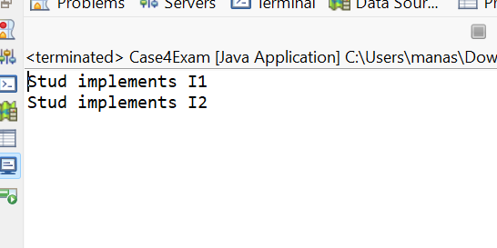
5. C1 implements C2 extends I1
Code:
package basics;
//Invalid:A class cannot implement another class
//implements is used only with interfaces
// C1 cannot implement C2
interface I3 {
void display1();
}
class C3 implements I3 {
public void display1() {
System.out.println("C3 implements I3");
}
}
class C4 extends C3 {
void display3() {
System.out.println("C4 extends C3");
}
}
public class Case5 {
public static void main(String[] args) {
C4 obj = new C4();
obj.display1();
obj.display3();
}
}
Explanation:
- I3 is an interface containing the method display1().
- C3 implements the interface I3.
- C3 provides the implementation of display1().
- display1() prints "C3 implements I3".
- C4 extends class C3.
- Therefore, C4 inherits the display1() method from C3.
- C4 also has its own method display3().
- An object obj of class C4 is created.
- obj.display1() calls the inherited method from C3.
- obj.display3() calls the method of C4, demonstrating inheritance between classes and interface implementation.
Output:
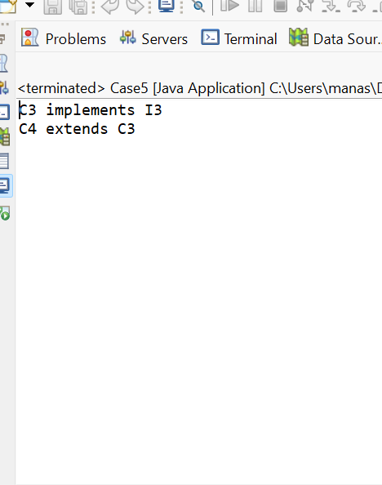
6. I1 extends I2
Code:
package basics;
//I1 extends I2
interface I4 {
void display2();
}
interface I5 extends I4 {
void display1();
}
class Demo implements I4 {
public void display1() {
System.out.println("I4 method");
}
public void display2() {
System.out.println("I5 method");
}
}
public class Case6 {
public static void main(String[] args) {
Demo obj = new Demo();
obj.display1();
obj.display2();
}
}
Explanation:
- I4 is an interface containing the method display2().
- I5 extends interface I4.
- Therefore, I5 inherits the display2() method from I4.
- I5 also contains its own method display1().
- Demo implements the interface I4.
- Demo provides the implementation of display2().
- Demo also defines display1(), even though it is not required by I4.
- An object obj of class Demo is created.
- obj.display1() and obj.display2() are called using the object.
- The program demonstrates interface inheritance using extends and interface implementation using implements.
Output:
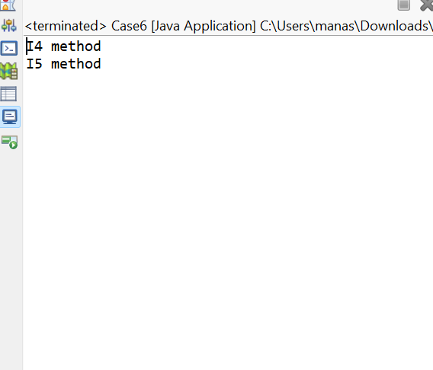
7. I1 implements C1
Code:
package basics;
//Invalid:An interface cannot implement a class
//I1 cannot implement C1
// implements is used by classes with interfaces
// correct implementation
interface I6 {
void display();
}
class C5 implements I6 {
public void display() {
System.out.println("C5 implements I6");
}
}
public class Case7 {
public static void main(String[] args) {
C5 obj = new C5();
obj.display();
}
}
Explanation:
- I6 is an interface containing the method display().
- C5 is a class that implements the interface I6.
- The keyword implements is used when a class implements an interface.
- C5 provides the implementation of the display() method.
- The display() method prints "C5 implements I6".
- An object obj of class C5 is created.
- The display() method is called using obj.
- The program prints the message on the screen.

- An interface cannot implement a class.
- This program demonstrates correct interface implementation using implements.
Output:
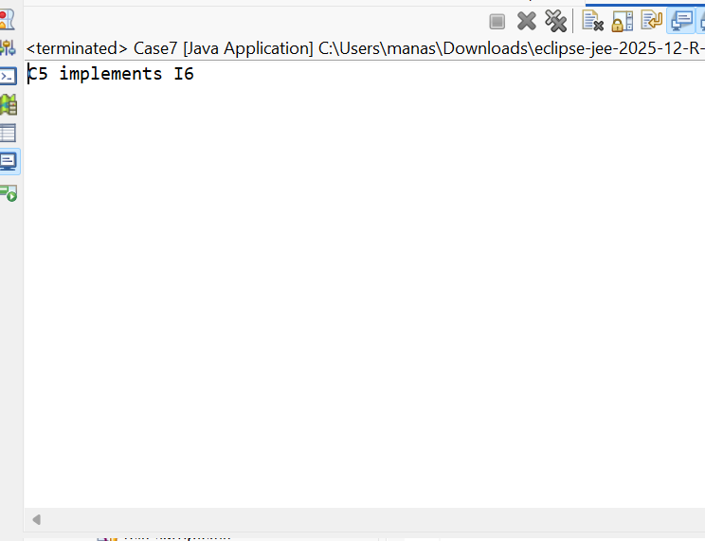
8. I1 extends I2, I3
Code:
package basics;
interface I8 {
void display2();
}

interface I9 {
void display3();
}

interface I7 extends I8, I9 {
void display1();
}
class Example implements I7 {
public void display1() {
System.out.println("I7 method");
}
public void display2() {
System.out.println("I8 method");
}
public void display3() {
System.out.println("I9 method");
}
}
public class Case8 {
public static void main(String[] args) {
Example obj = new Example();
obj.display1();
obj.display2();
obj.display3();
}
}
Explanation:
- I8 is an interface containing the method display2().
- I9 is another interface containing the method display3().
- I7 extends both I8 and I9.
- Therefore, I7 inherits the methods display2() and display3().
- I7 also has its own method display1().
- The class Example implements I7.
- Example provides implementations for all three methods.
- An object obj of class Example is created.
- The three methods are called using obj.
- This program demonstrates multiple inheritance between interfaces.
Output:
